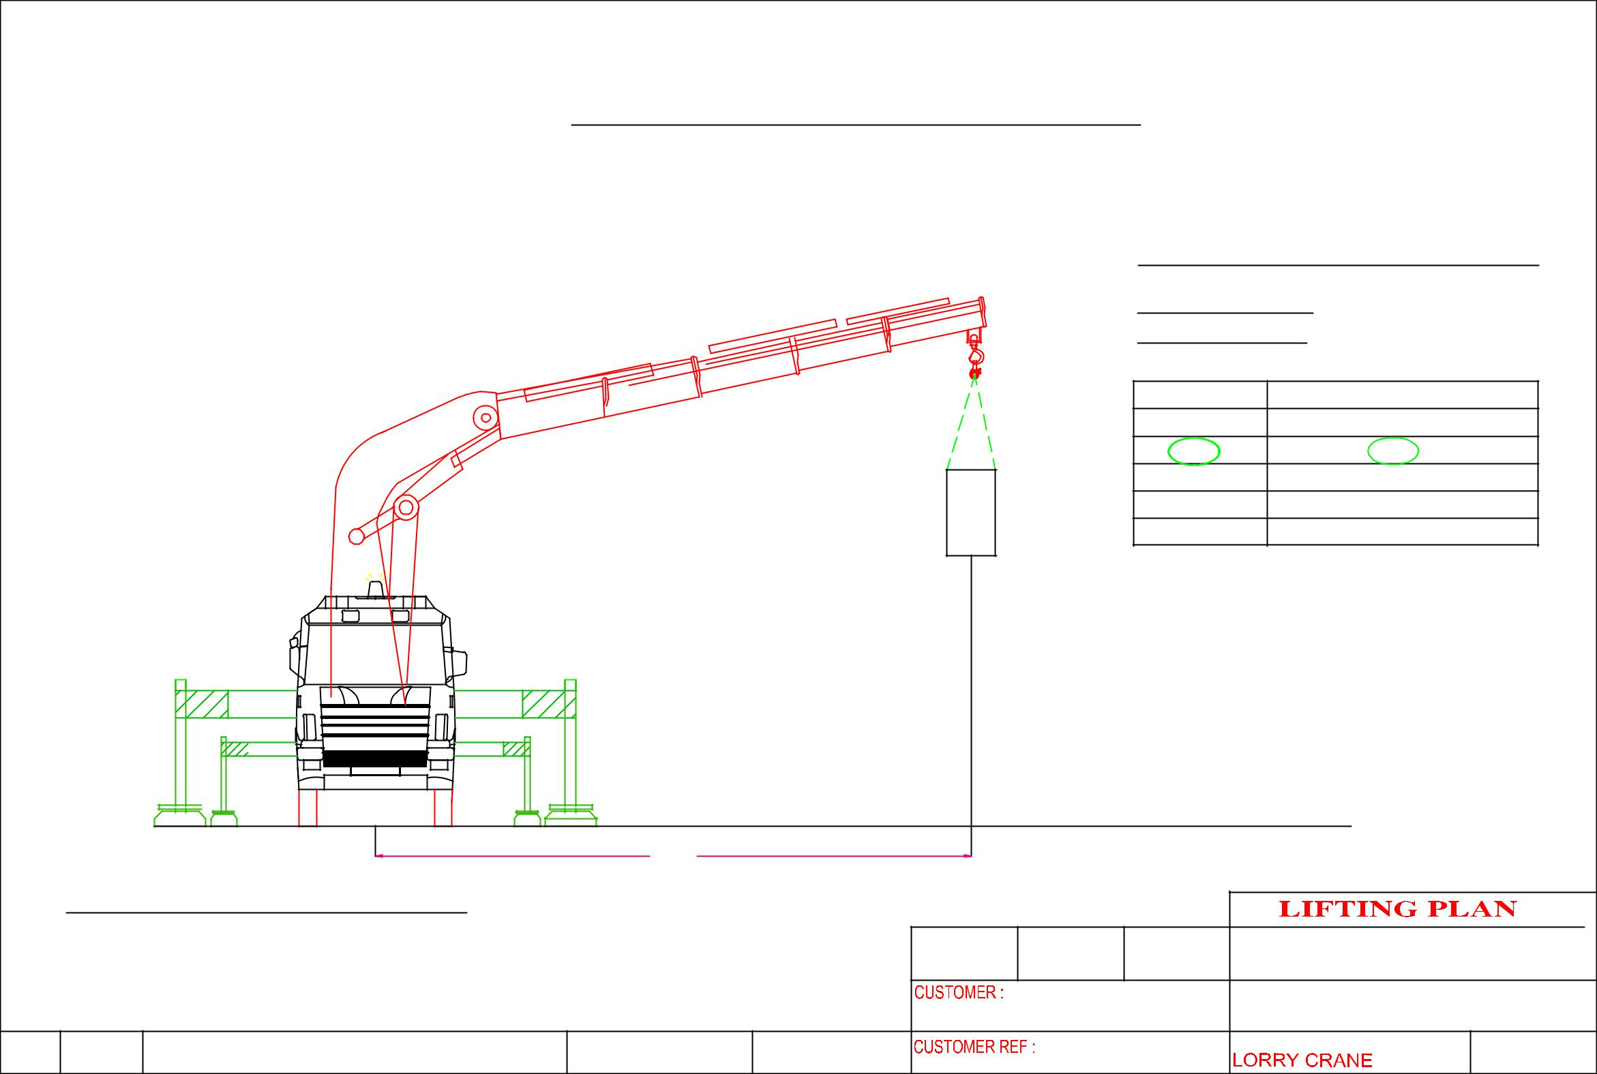
 |  |  | Hoisting of machine
 |  |  |  |  |  |  |  | CRANE: PALFINGER PK100002F
 |  |  |  |  |  |  |  | LORRY CRANE
 |  |  |  |  |  |  |  | CRANE CONFIGURATI0N
 |  |  |  |  |  | m6 |  | OPERATING RADIUS : 6m
 |  |  |  |  |  |  |  | ^{OPT . RADIUS(m)} |  | LIFTING CAPACITY OF CRANE IN KG
 |  |  |  |  |  |  |  | 4 |  |  | 16,900
 |  |  |  |  |  |  |  | 6 |  |  | 12, 200
 |  |  |  |  |  |  |  | 8 |  |  | 9, 100
 |  |  |  |  |  |  |  | 10 |  |  | 7, 100
 |  |  |  |  |  |  |  | 12 |  |  | 5,700
 |  |  |  |  | MACHINE WEIGHT: | 2,100 KG |  | SAFETY FACTOR CALCULATION
 |  |  |  |  |  |  |  | WEIGHT OF CARGO |  |  | : 2,100 KG
 |  |  |  |  |  |  |  | LIFTING ACCESSORIES WEIGHT : 50 KG
 |  |  |  |  |  |  |  | TOTAL WEIGHT OF LIFTING |  |  | : 2, 150 KG
 |  |  |  |  |  |  |  | LIFTING CAPACITY |  |  | :12, 200KG
 |  |  |  |  |  |  |  | SAFETY FACTOR |  |  | : 5, 6
 |  |  |  | 6M
 | CRANE: PALFINGER PK100002F
 |  |  |  |  |  | DRAWN | APPROVED | DATE | ERIC WONG MACHINERY TRANSPORTATION P/L
 |  |  |  |  |  |  | 10 Loyang Lane Cyrus Technology |  | DRAWING NAME:
 |  |  |  |  |  |  |  |  | HOISTING OF MACHINE

